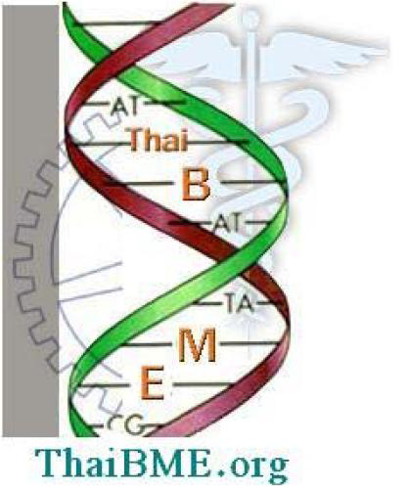
ThaiBME COPYRIGHT FORM
(Bound to BMECON)

Proceedings of Biomedical Engineering Conference (BMECON) held on August 1, 2019 at Srinakharinwirot University (SWU), Thailand.

Title of work: _____________________________________________________________________
_____________________________________________________________________
Author(s):
(1) ________________________________
(2) ________________________________
(3) ________________________________
(4) ________________________________
(5,6) ________________________________ ________________________________
TRASFER OF COPYRIGHT AGREEMENT
Copyright to the above work (including without limitation, the right to publish the work in whole or in part in any and all forms of media, now or hereafter known) is hereby transferred to the ThaiBME effective as of the date of this agreement on the understanding that the work has been accepted for publication by BMECON-2016 Conference.
However, each of the Authors retains the following rights:
• All other proprietary rights except copyright (and the publication rights transferred to ThaiBME), such as patent rights
• The right to reuse any portion of the work, without fee, in future works of the author's own.
This form must be signed by the Author (one of the authors who is authorized to transfer copyright on behalf of other co authors), before processing of the manuscript for publication can be completed. Authors should understand that consistent with the policy of ThaiBME in encouraging dissemination of information each published paper will appear with the following notice:
"Permission to make digital or hard copies of part or all of this work for personal or classroom use is granted without fee provided that copies are not made or distributed for profit or commercial advantage and that copies bear this notice and the full citation on the first page. Copyrights for components of this work owned by others than ThaiBME must be honored. Abstracting with credit is permitted. To copy otherwise, to republish, to post on servers or to redistribute to lists, requires prior specific permission from ThaiBME which may entail a fee."

Signature: ___________________________________
Print Name: __________________________________
Date: : _______________________

